|  |  |
| --- | --- |
|  | **THE MIZUHO SECURITIES**  **ASIA LIMITED** |

**Mizuho Securities Asia**

**Data Analytics Platform**

**Operation guide**

|  |  |
| --- | --- |
|  |  |
| Prepared by | Eastech Systems Limited |
| Document Version | v0.2 |
| Date | Dec 2, 2024 |

Revision History

|  |  |  |  |
| --- | --- | --- | --- |
| **Date** | **Author** | **Version** | **Description** |
| 2nd Dec, 2024 | Jasper Cheung | v0.1 | Document created. |
| 5th Dec, 2024 | Ellis Chiang | v0.2 | Formatting and additional content. |
|  |  |  |  |
|  |  |  |  |

Reviewers

|  |  |  |  |
| --- | --- | --- | --- |
| **Name** | **Position** | **Version** | **Date** |
|  |  |  |  |
|  |  |  |  |
|  |  |  |  |
|  |  |  |  |

Distributions

|  |  |  |
| --- | --- | --- |
| **Department** | **Name** | **Position** |
| Information Technology Department | Gordon Lo | Vice President |
|  |  |  |
|  |  |  |
|  |  |  |

**Table of Contents**

1 Introduction 6

1.1 Purpose of Document 6

1.2 Architecture of the Data Analytics Platform 6

2 RunMyJob Scheduler (RMJ) 7

2.1 Trigger a RMJ Job 7

2.2 Monitor RMJ Job Status 9

2.3 Resubmit a RMJ Job 9

2.4 Access the Log Message of a RMJ Job 9

2.5 Schedule and Alert 10

2.5.1 To Enable/Disable a Schedule 10

2.5.2 To Enable/Disable an Alert 11

3 Data Factory 12

3.1 Trigger An ETL Job 12

3.2 Monitor ETL Job Status 14

4 Synapse Dedicated SQL Pool 17

4.1 Resume and Pause Dedicated SQL Pool 17

4.2 Check the Log of Stored Procedure Executed 17

4.3 Check the Parameters of the Latest Run of a Report 19

5 SQL Server Reporting Services (SSRS) 21

5.1 Trigger a Report Subscription 21

5.2 Monitor Subscription Status 23

5.3 Restart Reporting Services 25

5.4 Check Report Server Log 26

6 Power BI Services 28

6.1 Refresh a Semantic Model (Dataset) 28

6.2 Update the Content of a Power BI App 28

7 Troubleshooting 31

7.1 Drill Down from RMJ Alert to Data Factory Monitor with Run ID 31

7.2 Common Issue 34

7.2.1 Repository Database is Inactive/Paused 34

7.2.2 Failed to Connect to Data Sources 35

7.2.3 Missing Input Files in Shared Folder 37

7.2.4 Report Subscription Execution Failure 39

7.2.5 Power BI Semantic Model Refresh Failure 41

# Introduction

## Purpose of Document

This operation guide is designed to provide a comprehensive understanding of the operation-related tasks on the key components of the Azure Data Analytics platform. These components include the RunMyJob (RMJ) scheduler, Data Factory, Synapse Analytics Workspace, SQL Server Reporting Services (SSRS), and Power BI service. It provides detailed instructions on essential tasks such as triggering and monitoring data pipelines, starting and stopping services, responding to alerts, and so on.

## Architecture of the Data Analytics Platform

The diagram below provides an overview of the architecture of the Data Analytics Platform.

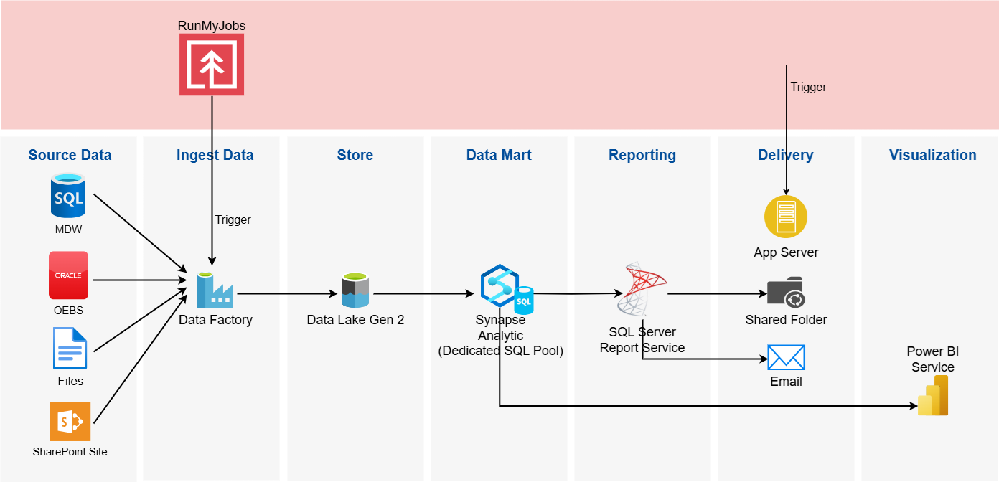

The architecture consists of the following Azure components:

* Data Factory: Orchestrates and automates data integration and ETL processes.
* Data Lake Gen 2: Scalable, secure, and cost-effective data lake storage solution.
* Synapse Analytics: Unified analytics platform for big data and real-time analytics.
* SQL Server Reporting Services (SSRS): Reporting platform for creating, deploying, and managing reports.
* Power BI Services: Cloud-based business analytics service for data visualization.

In brief, the Data Factory pipeline is designed to extract data from source databases and input files located in a shared folder. It transfers the necessary data into the Azure Data Analytics Platform, where it is stored in the data lake. This data is then mounted to the SQL Pool in Synapse Analytics as an external table, creating a result data set for reporting. SQL Server Reporting Services (SSRS) generates reports using these result datasets. The generated reports can either be saved in the shared folder or sent via email, depending on the subscription settings in SSRS. Additionally, Power BI services will be used to visualize the data in the SQL Pool through a dashboard.

# RunMyJob Scheduler (RMJ)

RMJ serves as the central entry point for managing and automating the ETL process and report generation within the Data Platform. Through RMJ, users can efficiently schedule, monitor, and manage the lifecycle of the report process.

## Trigger a RMJ Job

1. In the RMJ portal, navigate to the **Process Definitions** / **Chain Definition** tab.
2. Search by Keywords on the search bar to filter the corresponding process definition/chain definition.
3. To Trigger a process definition, right-click on the row, and click on “**Submit**”.

1. A Submit Process window will then show up, check the parameter values before submission. Click on “**Submit**”.

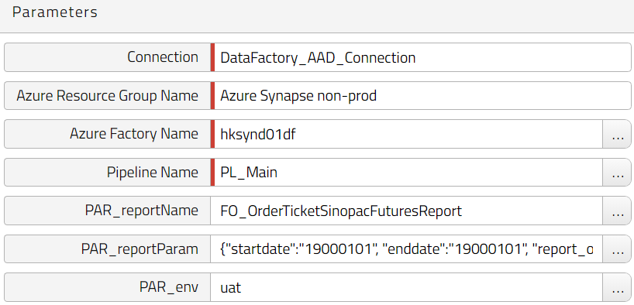

1. To Trigger a chain definition, right-click on the row, and click on “**Edit**”.

1. An Edit Chain Definition window will then show up. In the diagram, click on the process that triggers a data factory pipeline. Click on the blue arrow on the right pane to toggle the text fields form. Update the report parameter values if required. Click on “**Save and Close**”.

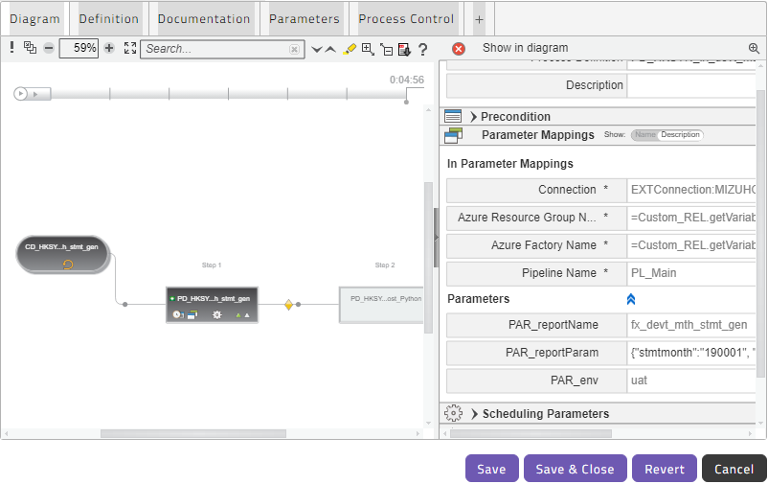

1. Right-click on the chain definition row again and click on “**Submit**”.
2. A Submit Process window will then show up, click on “**Submit**”.

## Monitor RMJ Job Status

1. In the RMJ portal, navigate to the **Process Definitions** / **Chain Definition** tab.
2. Search by Keywords on the search bar to filter the corresponding process definition/chain definition.
3. To Monitor the job status of historical runs. Right-click on the row and click on “**Monitor related processes**”.
4. The Related Processes tab will show up, and the list of previous runs will be displayed from the most recent run to the oldest run.

## Resubmit a RMJ Job

1. In case a process or chain encounters an error and requires a job resubmission, in the RMJ portal, navigate to the failed job in the processes monitoring tab or monitor related processes tab.
2. Right-click on the failed job entry and select “**Resubmit**” from the menu.

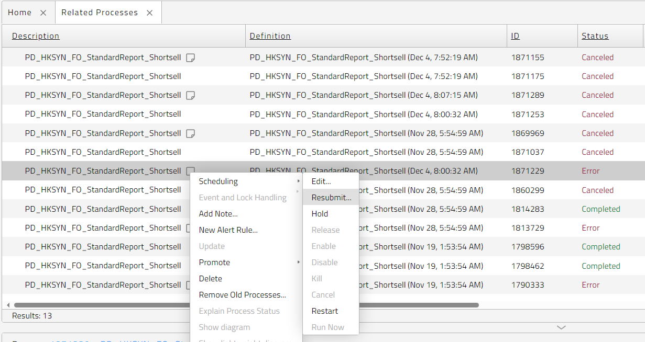

## Access the Log Message of a RMJ Job

1. In the RMJ portal, navigate to the process or chain from the processes monitoring tab or monitor related processes tab.
2. Highlight the job entry that needs to access the job log.

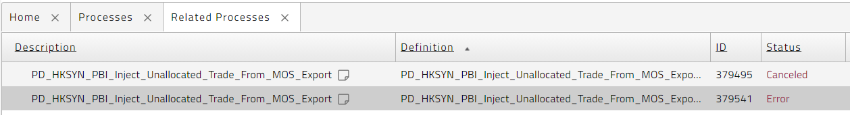

1. In the process details pane, scroll down to “**Files**” and there will be a “**stdout.log**” and/or a “**stderr.log**” (depending on setup and remote system type) attached to the RMJ process. The log message from the remote system can be located in these log files.

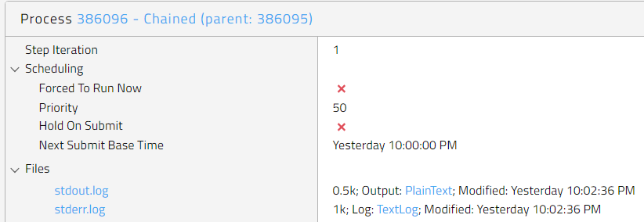

## Schedule and Alert

The schedule and alert information are configured in the “**Documentation**” tab on the “**Edit Process Definition**” or “**Edit Chain Definition**” window.

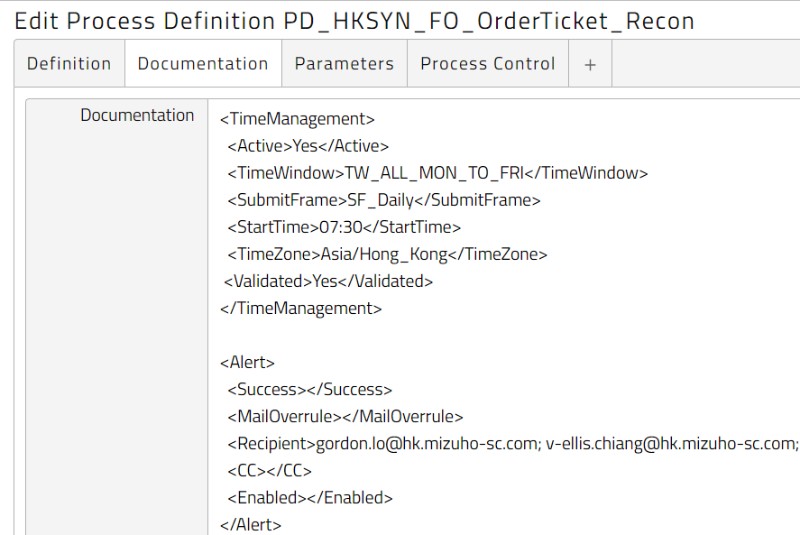

### To Enable/Disable a Schedule

1. To enable or disable a schedule of a process or chain, can be achieved by updating the value of the **“<Active>**” tag in the “**<TimeManagement>**” section of the “**Documentation**”. Using the value “**Yes**” for enable and “**No**” for disable. Click “**Save & Close**” to save the change.
2. Right-click on the process or chain and select “**Synchronize Job(s)**” from the menu to enable or disable a schedule.

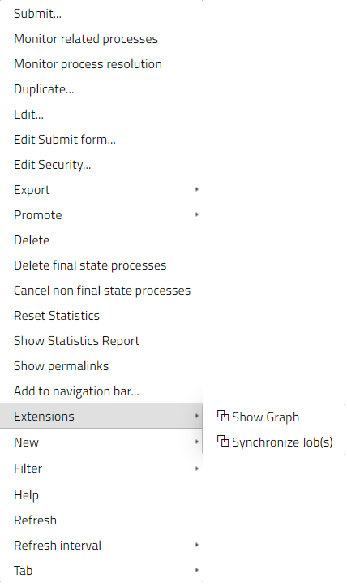

### To Enable/Disable an Alert

1. To enable or disable an alert of a process or chain, it can be achieved by updating the value of the **“<Enabled>**” tag in the “**<Alert>**” section of the “**Documentation**”. Using value “**Yes**” for enable and “**No**” for disable. By default, it is enabled for a blank value. Click “**Save & Close**” to save the change.
2. The alert does not require synchronizing job after the setting has been updated. The change will take effect in the next job submission.

# Data Factory

## Trigger An ETL Job

1. In Azure Portal, navigate to **Azure Data Factory**.
2. Access the target Azure Data Factory by clicking the name from the list.

DEV: hksynd01-df  
PROD: hksynp01-df

1. Click on “**Launch studio**” and Azure Data Factory Studio will be started in a new browser tab.

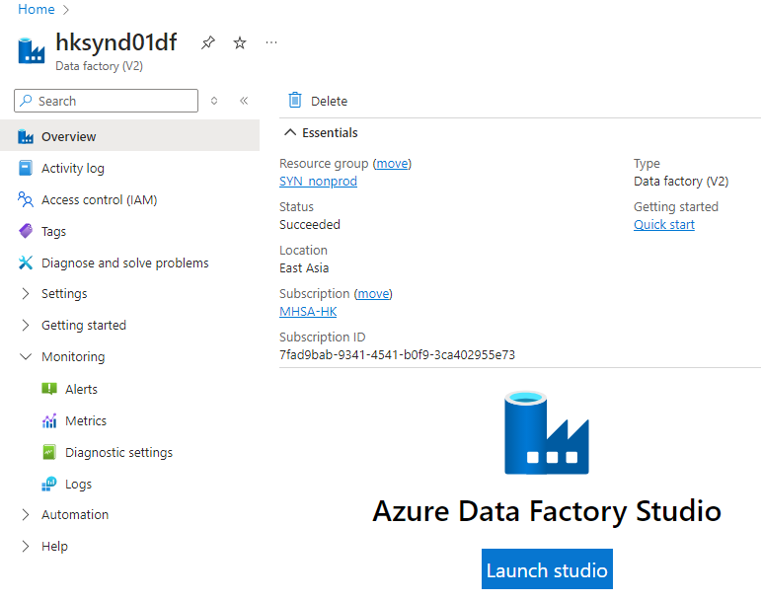

1. To trigger an ETL job for a report, go to “Author” in the side menu. Expand “**Pipelines**” and click on “**PL_Main**” under the “**Mizuho**” folder.

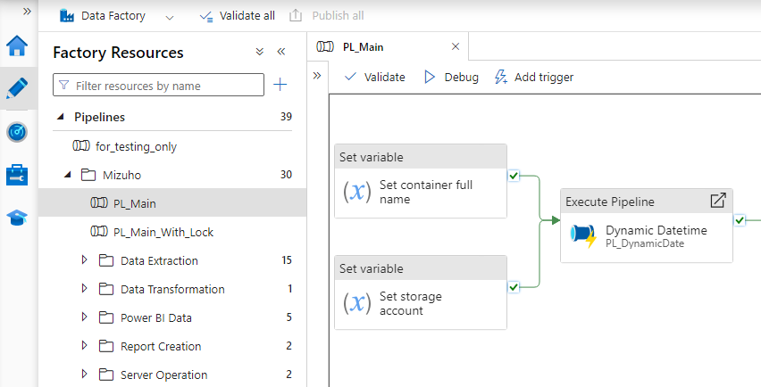

1. On the main canvas, click on “**Add Trigger**”, select “**Trigger Now**”.

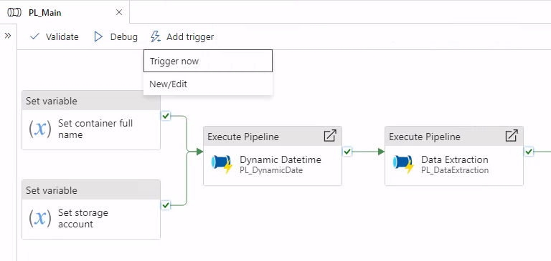

1. A parameter panel will be shown on the right, fill in the parameter values. Click on “**OK**”.

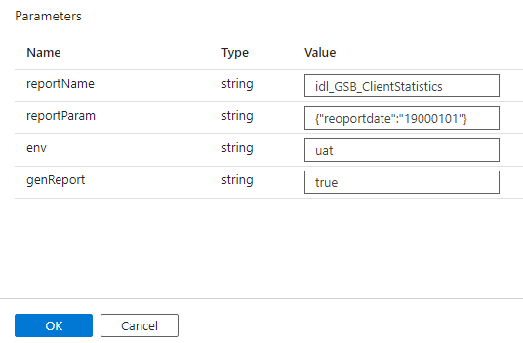

1. The pipeline will be triggered. The output status can be found on the “Output” tab at the bottom.

## Monitor ETL Job Status

1. In Azure Portal, navigate to **Azure Data Factory**.
2. Access the target Azure Data Factory by clicking the name from the list.

DEV: hksynd01-df  
PROD: hksynp01-df

1. Click on “**Launch studio**” and Azure Data Factory Studio will be started in a new browser tab.



1. To monitor the status of the pipeline execution, go to “**Monitor**” in the side menu. Select “**Pipeline runs**” from the Table of content pane and click on “**Triggered**”.

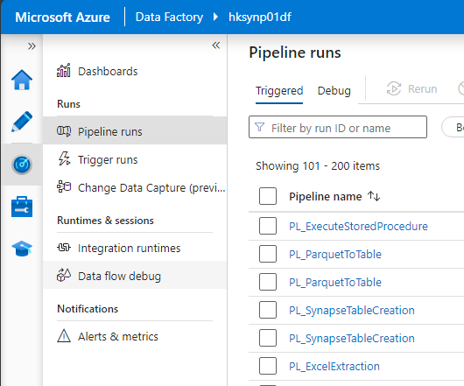

1. To further narrow down the number of pipelines being shown in the Monitor’s Pipeline runs pane, enter a keyword of a pipeline name in the search box.

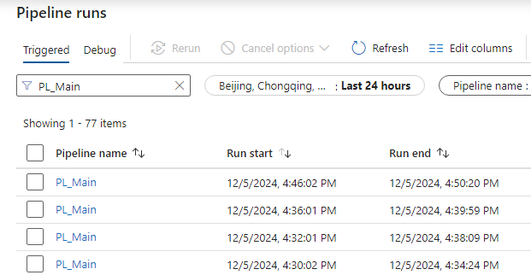

1. Click on the pipeline name to show the status of each activity being executed in the pipeline.

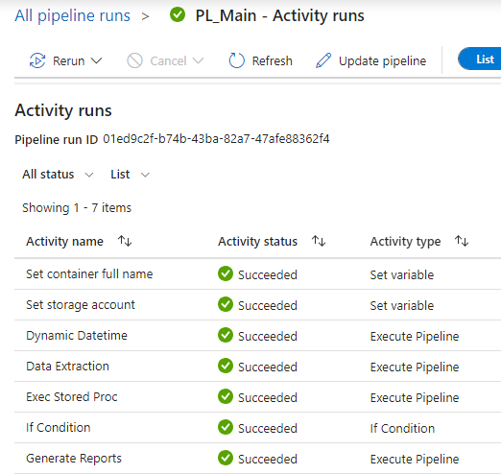

1. To further drill into any sub-pipelines from the root pipeline, highlight the sub-pipeline and then click on the output arrow button. A pop-up box will be shown and click on the link of the pipeline ID.



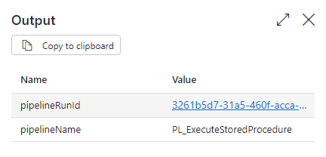

1. It will then drill down to the desired sub-pipeline and show all the activities and the corresponding status. Repeat above steps to drill down to another sub-pipeline if needed.
2. To go back to the pipelines(s) in the upper level, use the navigation bar on the top to go back to the previous level by directly clicking on the name of the pipeline in the navigation bar.



# Synapse Dedicated SQL Pool

## Resume and Pause Dedicated SQL Pool

1. In the Azure portal, navigate to **Azure Synapse Analytic**.
2. Expand Analytics pools on the left side menu, click on “**SQL pools**”.

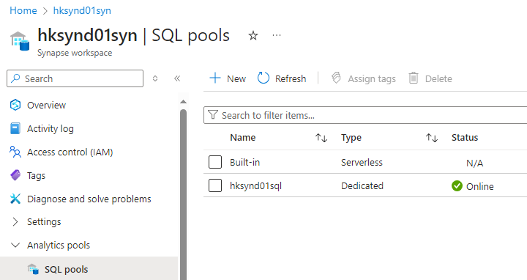

1. To pause a dedicated SQL pool, right click on the row and then click “**Pause**”.

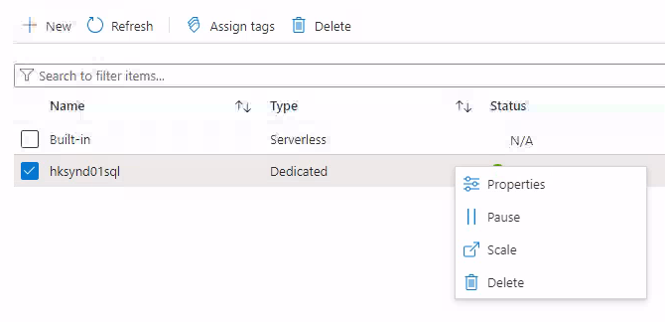

1. To resume a dedicated SQL pool, right click on the row and then click on “**Resume”**.

## Check the Log of Stored Procedure Executed

1. In the Azure portal, navigate to **Azure Synapse Analytics**.
2. Access the target Synapse workspace by clicking the name from the list.
3. Click on “**Open**” and Azure Synapse Studio will be started in a new browser tab.

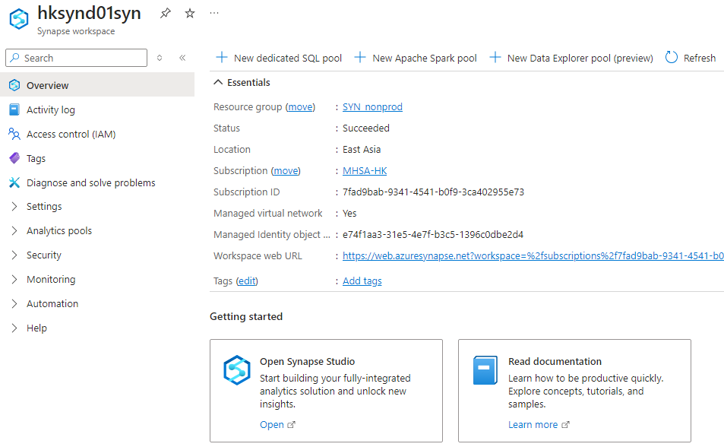

1. Navigate to “**Data**” in the left menu, right click on the Database, and then click on “**Empty script**”.

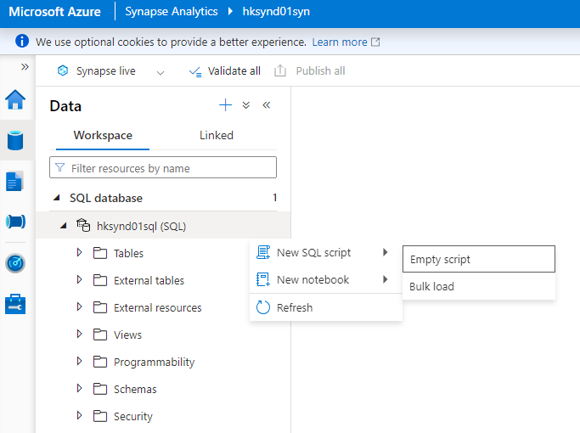

1. A new SQL script will pop-up, SQL statement can be executed.
2. To check the execution log of a stored procedure, query from the table “**log_stored_procedure**”.

SELECT * FROM log_stored_procedure

WHERE ProcudureName = '<prodcedure_name>'

ORDER BY StartAt DESC;

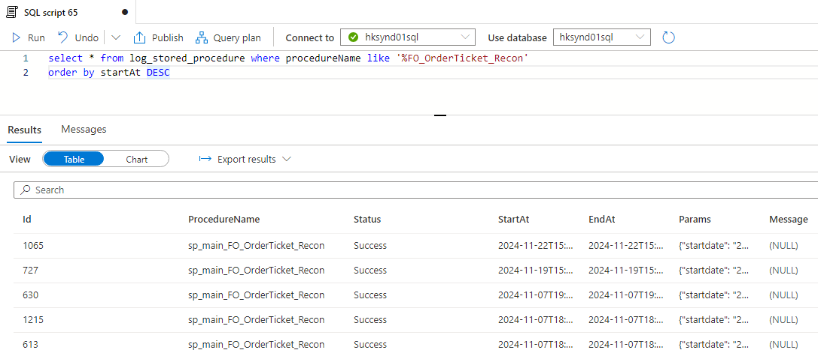

## Check the Parameters of the Latest Run of a Report

1. In the Azure portal, navigate to **Azure Synapse Analytics**.
2. Access the target Synapse workspace by clicking the name from the list.
3. Click on “**Open**” and Azure Synapse Studio will be started in a new browser tab.



1. Navigate to “**Data**” in the left menu, right click on the Database, and then click on “**Empty script**”.



1. A new SQL script will pop-up, SQL statement can be executed.
2. To check the parameter used in the latest run, query “**LastReportParam**” from the table “**config_rpt_filter**”.

SELECT LastReportParam FROM config_rpt_filter

WHERE ReportName = '<report_name>';

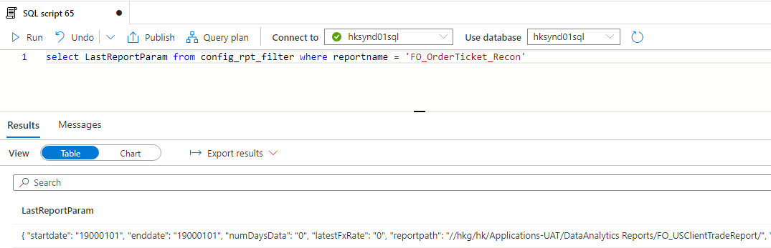

# SQL Server Reporting Services (SSRS)

## Trigger a Report Subscription

1. Access the Reporting Services portal with a web browser.

DEV: [Home - SQL Server 2019 Reporting Services](https://hkwninsqld041v/Reports/browse?_fr=1)

PROD: [Home - SQL Server 2019 Reporting Services](https://hkwninsqlp034v/Reports/browse?_fr=1)

1. In the Reporting Services Home, select the corresponding folder of a report.

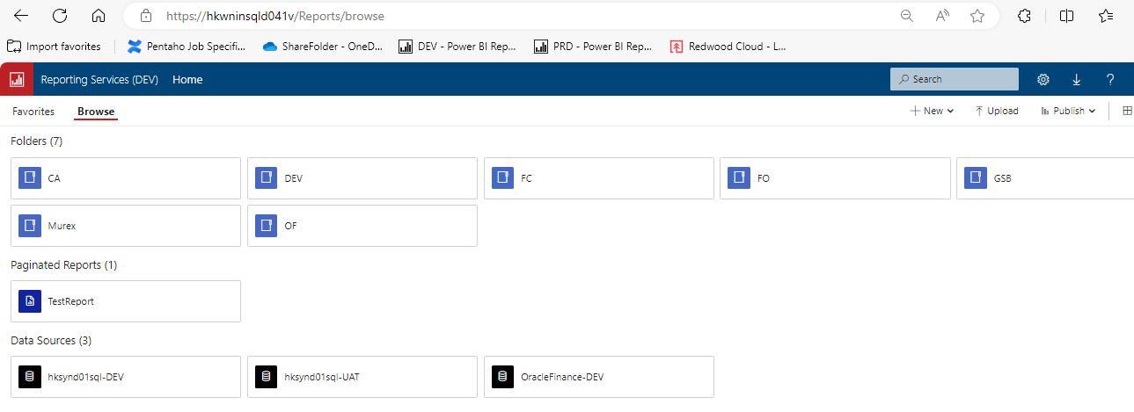

1. Hover on a report, click on the “**ellipse**” icon. From the menu, select “**Manage**”.

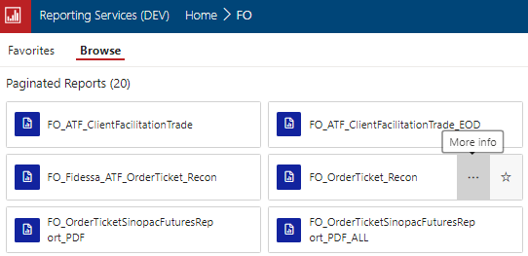

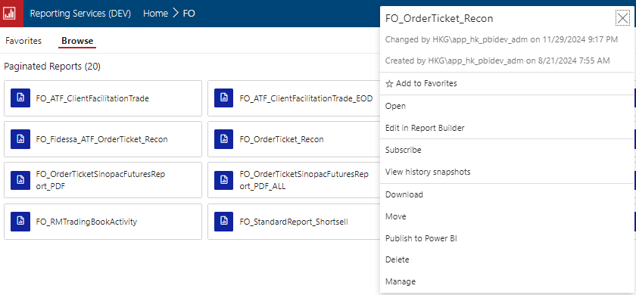

1. Click on “S**ubscriptions**” on the left menu, the subscription table will be displayed.

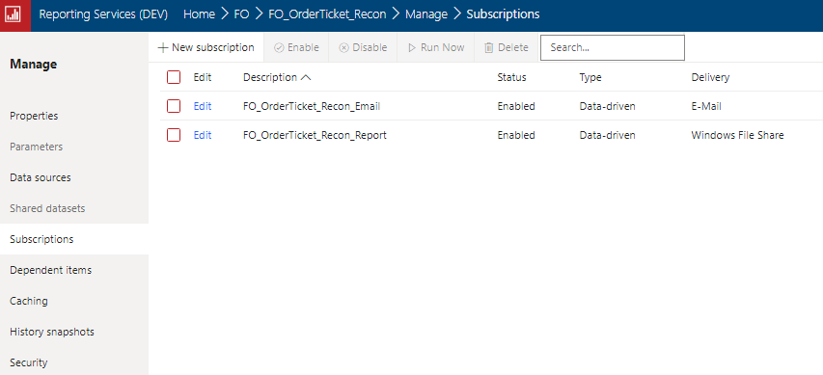

1. To trigger a report subscription, check the checkbox and then click on “**Run Now**”.

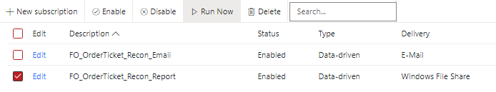

## Monitor Subscription Status

1. Access the Reporting Services portal with a web browser.

DEV: [Home - SQL Server 2019 Reporting Services](https://hkwninsqld041v/Reports/browse?_fr=1)

PROD: [Home - SQL Server 2019 Reporting Services](https://hkwninsqlp034v/Reports/browse?_fr=1)

1. In the Reporting Services Home, select the corresponding folder of a report.



1. Hover on a report, click on the “**ellipse**” icon. From the menu, select “**Manage**”.





1. Click on “**Subscriptions**” on the left menu, the subscription table will be displayed.



1. The last run time and the result message of a subscription will be displayed in the table.



## Restart Reporting Services

1. Use a remote desktop connection to connect to the Report Server.

**DEV**: hkwninsqld041v  
**PROD**: hkwninsqlp034v

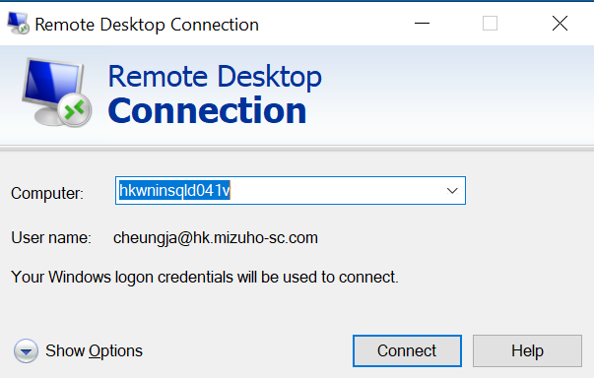

1. Open the desktop APP “**Report Server Configuration Manager**”.
2. To restart the reporting services, click on “**Stop**” and then resume by clicking on “**Start**”.

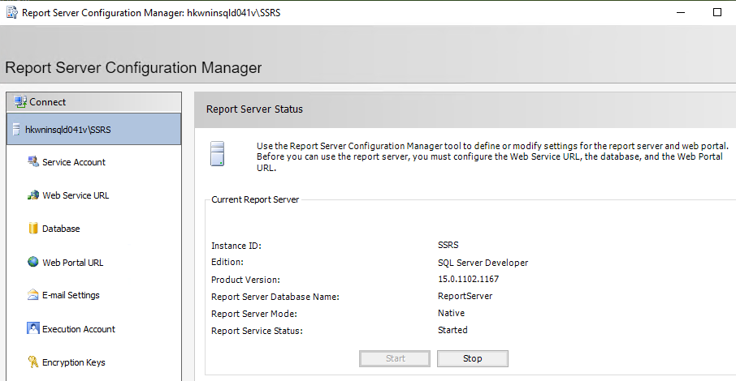

## Check Report Server Log

1. Use remote desktop connection to connect to the Report Server.

**DEV**: hkwninsqld041v  
**PROD**: hkwninsqlp034v



1. With File Explorer, go to the folder “**C:\Program Files\Microsoft SQL Server Reporting Services\SSRS\LogFiles**”.
2. The detail logs are written to files with prefix “**ReportingServicesService_**” and suffix in date time format “**yyyy_MM_dd_HH_mm_ss**”.

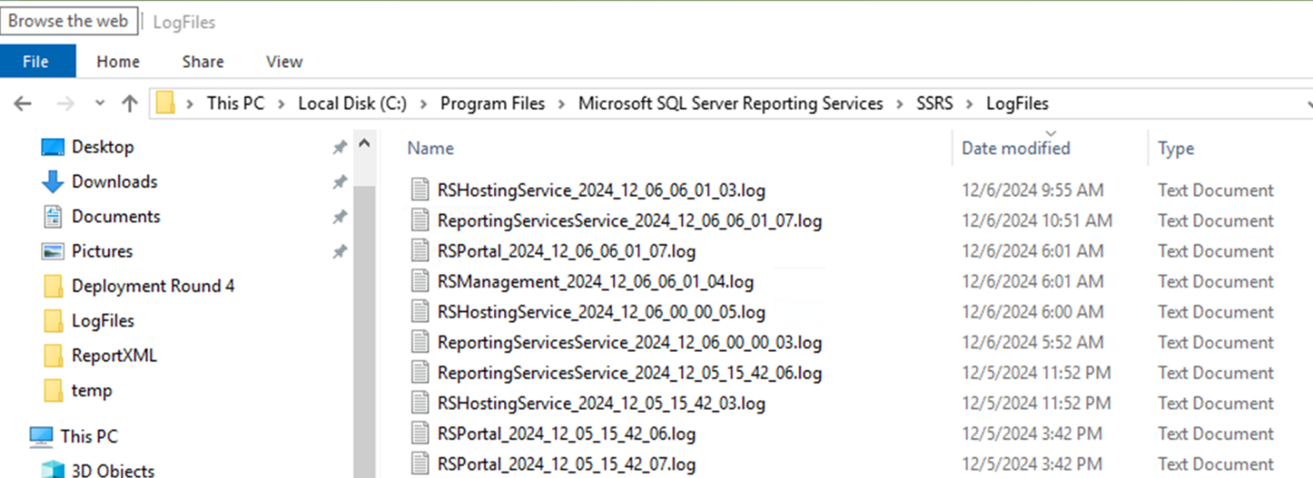

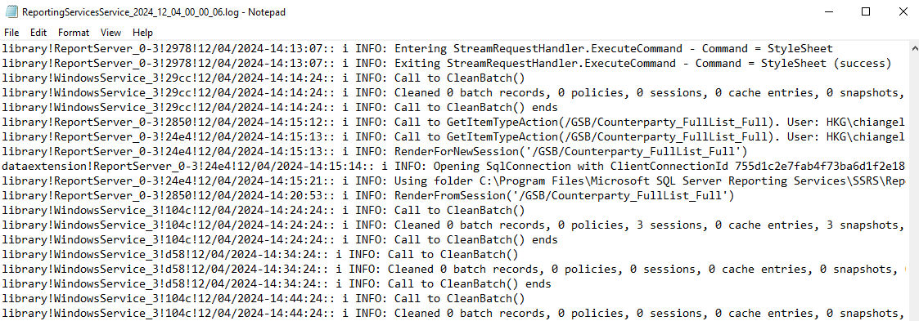

# Power BI Services

## Refresh a Semantic Model (Dataset)

1. Access the Power BI services portal, <https://app.powerbi.com/>, with a web browser.
2. By using the navigation bar on the left-hand side, go to the Workspace where the semantic model is located.

DEV: DA Workspace (DEV)

PROD: DA Workspace

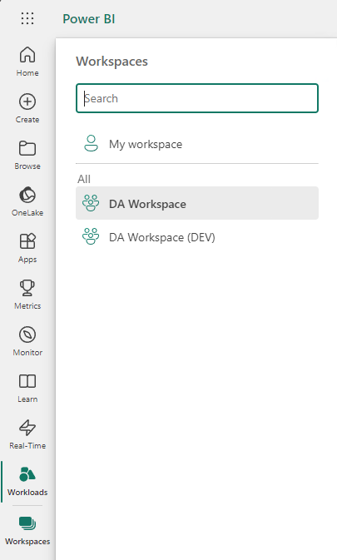

1. Hover on the semantic model and click the “**Refresh now**“ button to trigger a manual refresh.

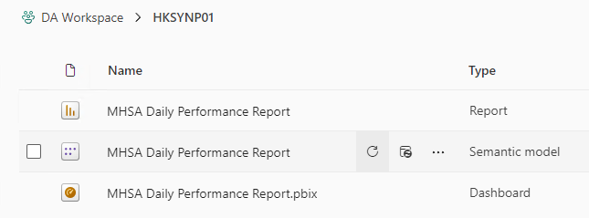

## Update the Content of a Power BI App

1. Access the Power BI services portal, <https://app.powerbi.com/>, with a web browser.
2. By using the navigation bar on the left-hand side, go to the Workspace where the Power BI App being created and shared.

DEV: DA Workspace (DEV)

PROD: DA Workspace



1. Click on “Update app” on the upper right corner to update the Power BI app.

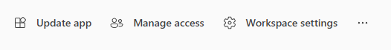

1. If there are new audience need to grant the access to the Power BI app or a user found he/she does not have access to the Power BI App in their Power BI services portal, then go to the “**Audience**” tab and grant the access to the user by using the “**Edit Audience**” pane on the right-hand side of the page.

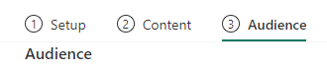

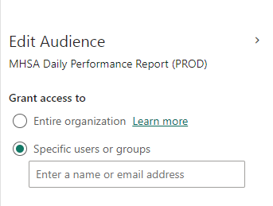

1. If the dashboard has been updated, then go to the “Content” tab and check the content of the dashboard. When a dashboard has been updated, say for instance added additional visual or change on the filter condition, a manual update on the Power BI App is required.

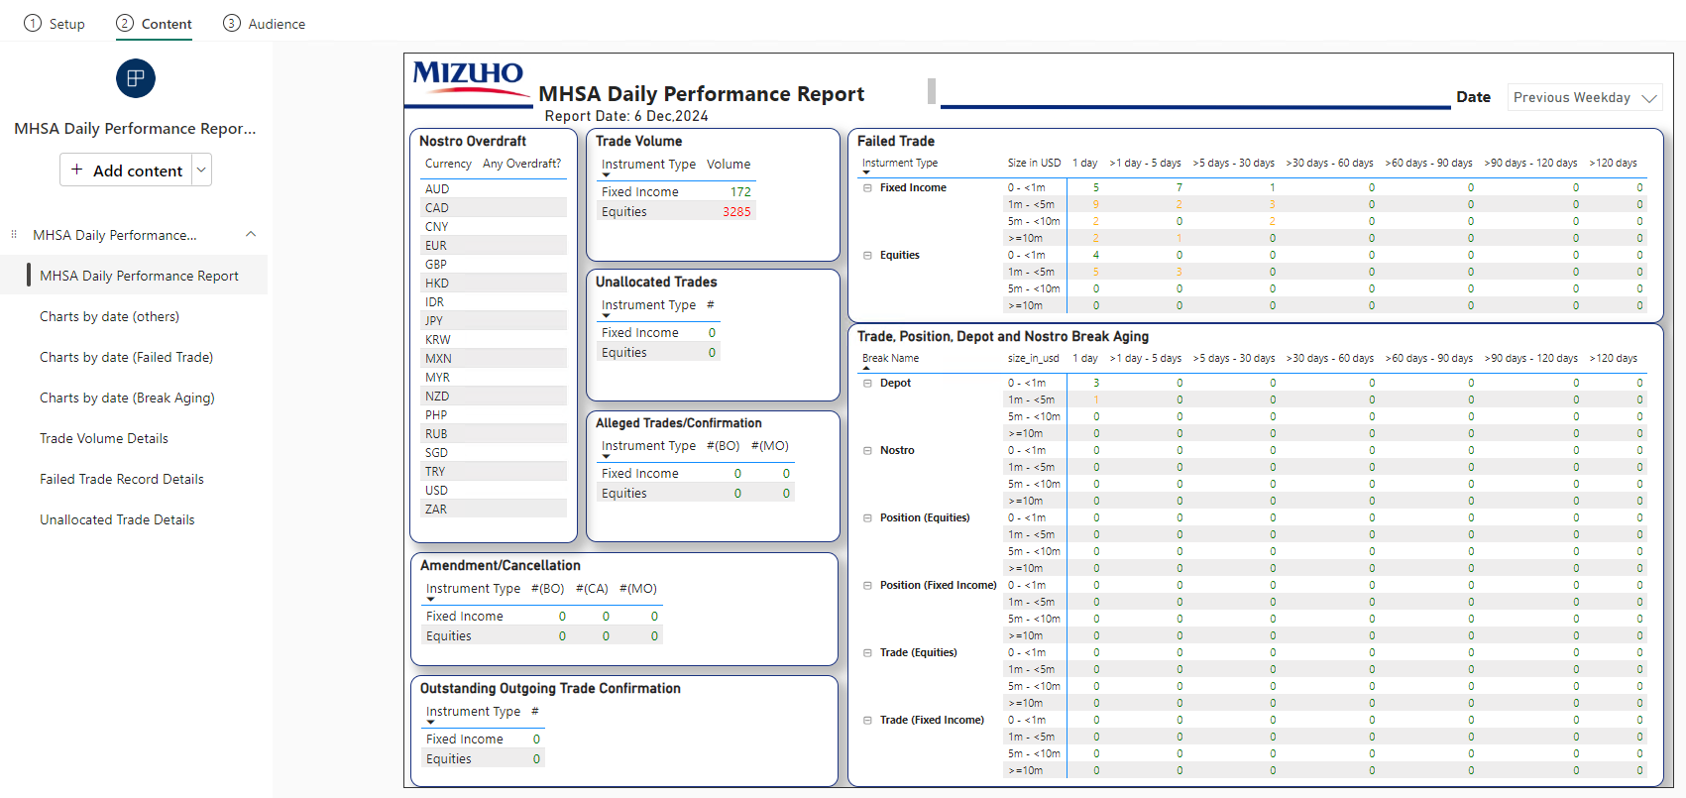

1. After completing the update on the either content or audience, click on the “Update App” button in the lower right corner to apply the update on the Power BI App.



# Troubleshooting

## Drill Down from RMJ Alert to Data Factory Monitor with Run ID

1. When a RMJ job fails, an email alert is triggered. This email includes a Run ID, which matches the Data Factory pipeline Run ID.

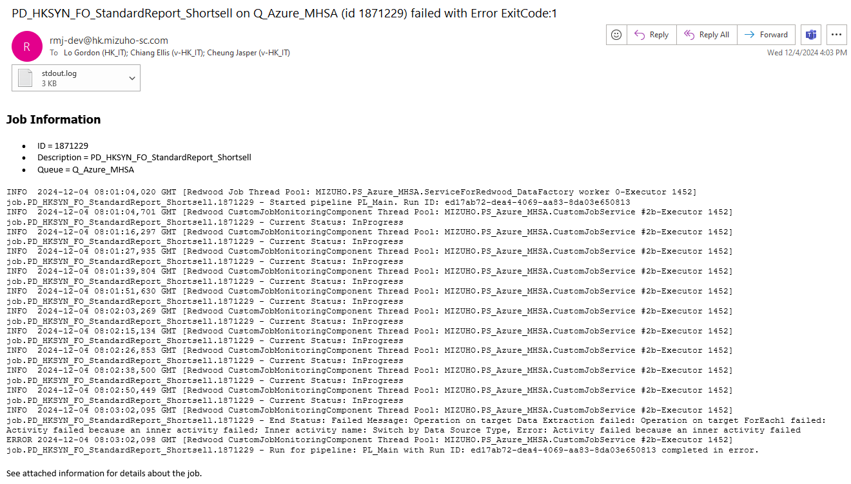

1. An alternative way to retrieve the Run ID of the pipeline is through the RMJ console. In the RMJ console, navigate to the process (job) that encountered an error during execution.

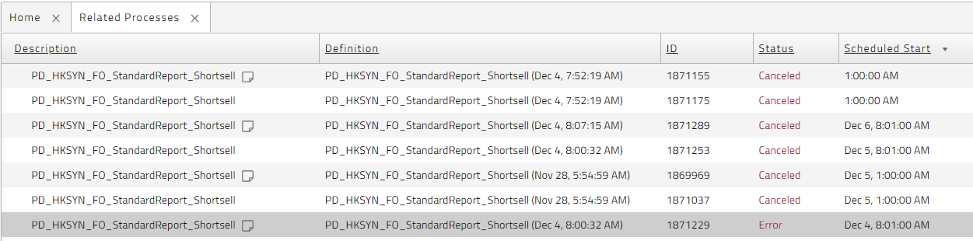

1. In the process details pane, scroll down to “**Files**” and click on “**stdout.log**” to open the log.

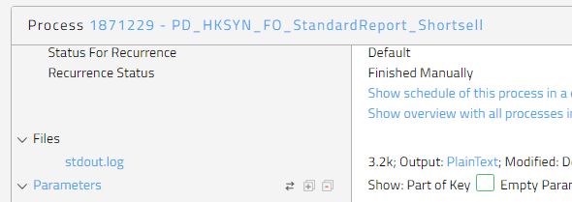

1. The pipeline Run ID can then be located from the last entry of the log.

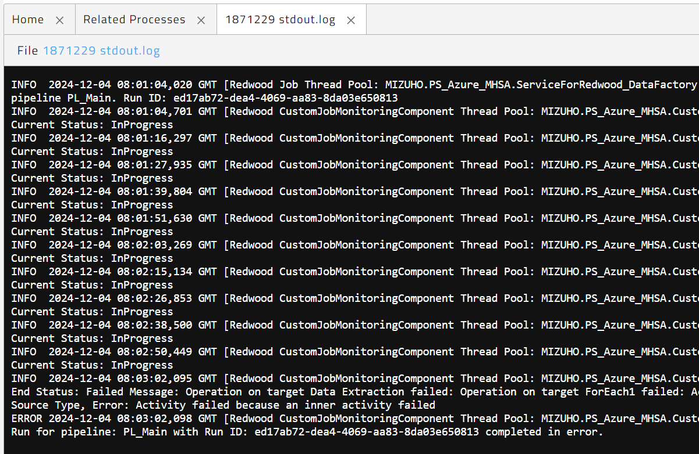

1. In Azure Portal, navigate to **Azure Data Factory**.
2. Access the target Azure Data Factory by clicking the name from the list.

**DEV**: hksynd01-df  
**PROD**: hksynp01-df

1. Click on “**Launch studio**” and Azure Data Factory Studio will be started in a new browser tab.



1. Go to “**Monitor**” in the side menu, select “**Pipeline runs**” from the Table of Contents pane, and click on the “**Triggered**” tab.



1. To drill down the pipeline that encountered an error, copy & paste the Run ID in the search box.

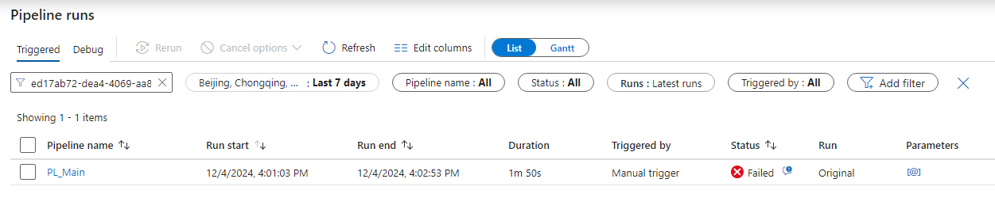

1. Follow the steps in section 3.2. to drill down the error of a sub-pipeline.

## Common Issue

### Repository Database is Inactive/Paused

The report creation pipeline in the Data Factory has been set up to use the Synapse Dedicated SQL Pool as its report job repository. The pipeline cannot execute without access to the report job repository. According to the log message (see section 2.4 for details on accessing the job log), the Synapse Dedicated SQL Pool at hksynd01syn.sql.azuresynapse.net is currently unreachable, which has led to the failure of the pipeline.

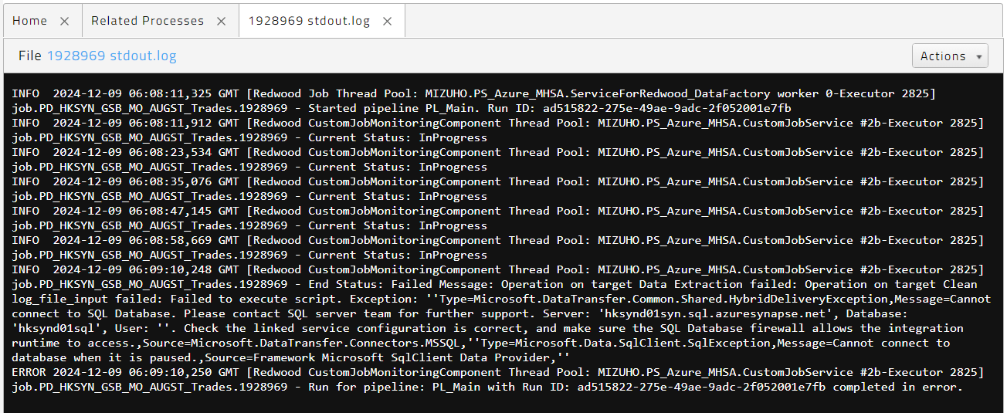

Possible cause of the error:

* The Synapse Dedicated SQL Pool was paused.
* The database connection configuration is incorrect.
* Service outage of the Synapse Dedicated SQL Pool.

### Failed to Connect to Data Sources

The report pipeline is designed to copy data from a source database located in an on-premises system to the Azure Synapse Dedicated SQL Pool for data processing and report generation. Failure to establish a connection to the source database will result in the failure of the pipeline. However, the log message (see section 2.4 for access to the job log) lacks clarity in identifying the underlying cause of the issue, as the error originates from the sub-pipeline. To identify the root cause, it will be necessary to utilize the Run ID from the log and perform a detailed examination of the sub-pipeline, as outlined in section 3.2.

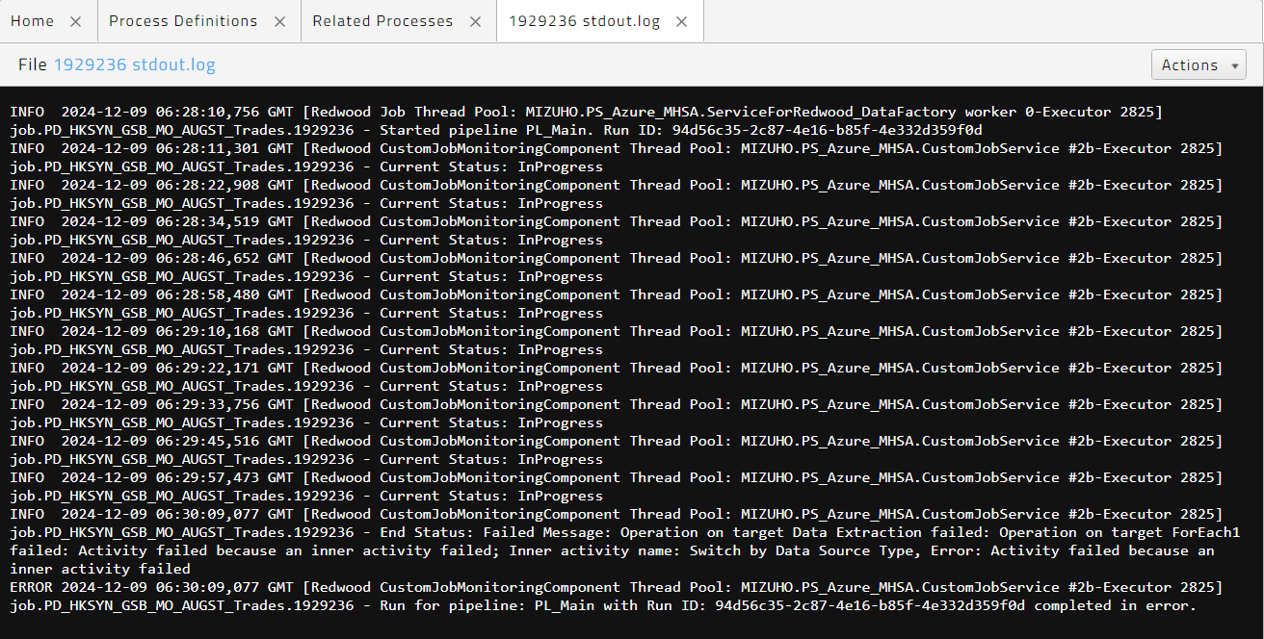

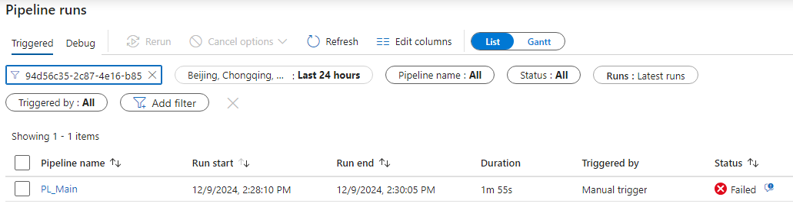

Upon conducting a detailed analysis of the sub-pipeline, an error was identified during the database extraction phase. To gain insight into the issue, click the information button associated with the "Failed" status. This action will display the error message generated when the pipeline attempts to connect to the source database. In the example provided below, the source of the error was identified as a login failure for the specified user account.

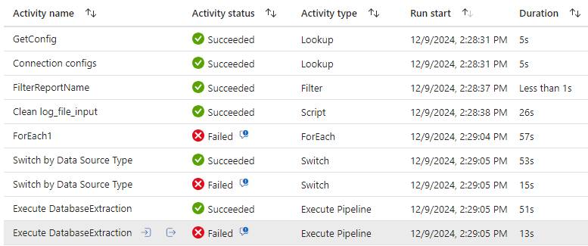

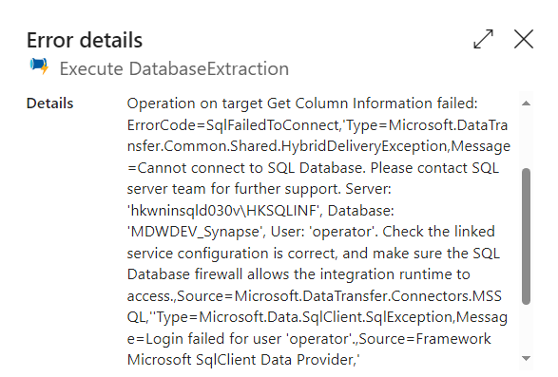

Possible cause of the error:

* Login credentials are incorrect.
* The source database is out of service.
* The database connection configuration is incorrect.

### Missing Input Files in Shared Folder

Some reports depend on input files generated by other systems and stored in a shared folder. The inability to read the input files specified for the report job will result in a failure of the pipeline. The log message (see section 2.4 for job log access) does not provide sufficient clarity to pinpoint the cause of the issue, as the error originates from the sub-pipeline. It will be necessary to utilize the Run ID from the log and conduct a thorough investigation of the sub-pipeline in order to ascertain the root error message, as outlined in section 3.2.

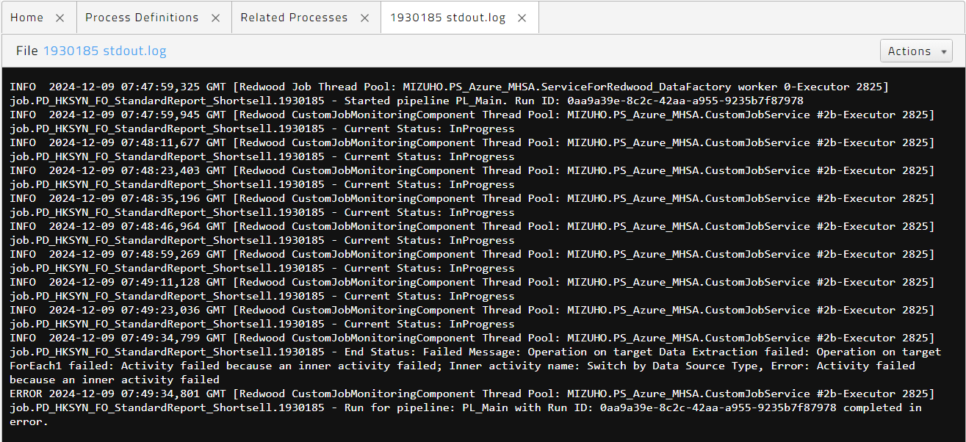

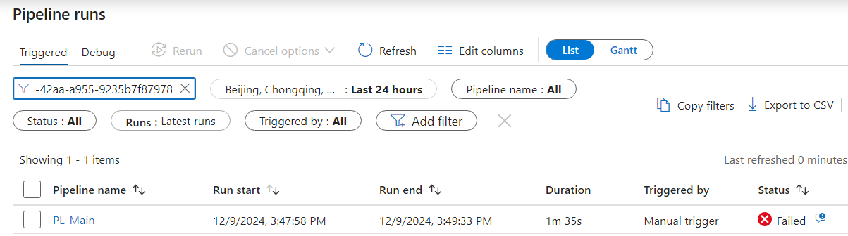

After examining the sub-pipeline, an error occurred during the extraction of the Excel file. Click the information button next to the "Failed" status to view the error message returned when the pipeline attempted to access the specified input file from the shared folder. In the example below, the error was caused by the file not being found in the specified path.

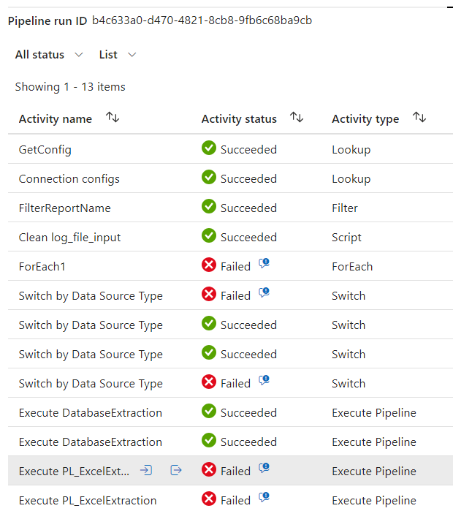

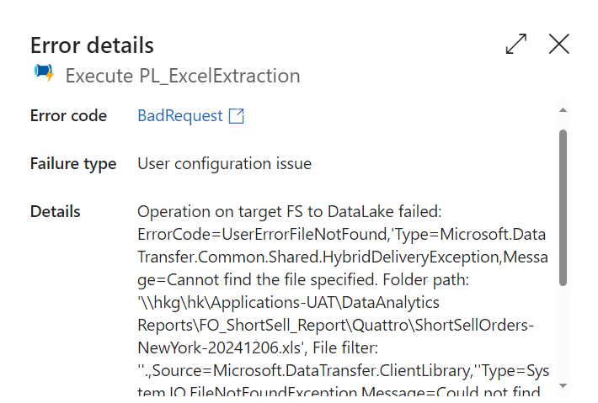

Possible cause of the error:

* The input file does not exist.
* Access denied to the input file path.
* The credential for accessing the shared folder is not valid.

### Report Subscription Execution Failure

The pipeline encounters a failure when report generation within SQL Server Reporting Services (SSRS) is unsuccessful. According to the log message (refer to section 2.4 for access to the job log), the message lacks sufficient clarity to pinpoint the underlying cause of the issue, as the error arises from the sub-pipeline. To determine the root cause, it is necessary to utilize the Run ID from the log and investigate the sub-pipeline to uncover the specific error message, as detailed in section 3.2.

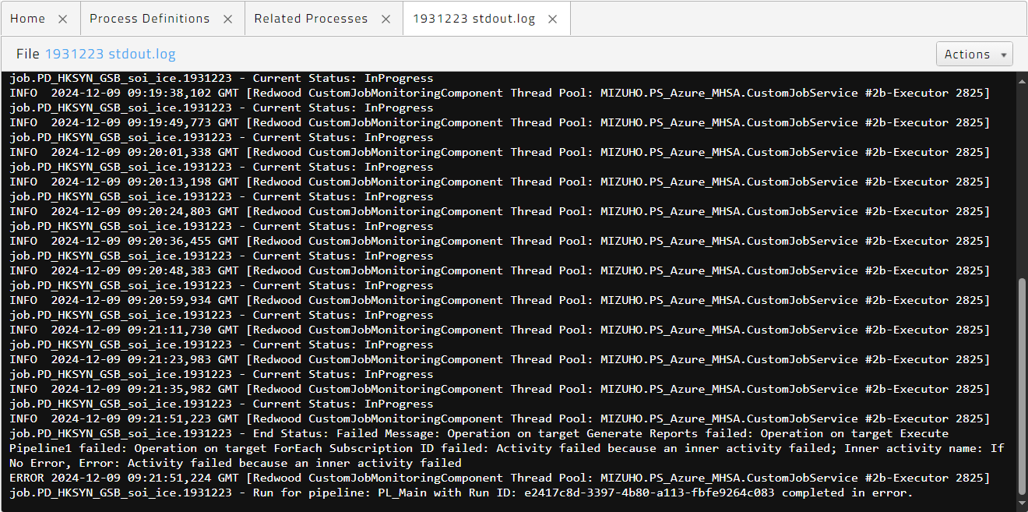

Upon examining the sub-pipeline, an error was encountered during the execution of the report subscription. To access the error message generated when the pipeline attempted to produce a report using SSRS, click the information button adjacent to the "Failed" status. For detailed instructions on retrieving the actual error message from SSRS, kindly refer to section 5.4, which outlines the procedures for accessing the reporting services log file.

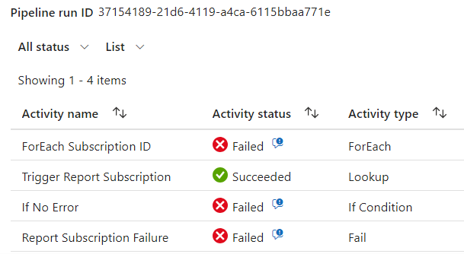

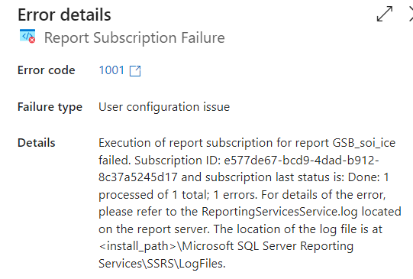

In the error message displayed within the Data Factory information box, the relevant subscription ID associated with the report is provided in the error details. This subscription ID can be utilized to locate related entries in the report server's reporting services log. For example, in the case presented below, the issue arose due to SSRS's failure to write the output file to the specified output path.

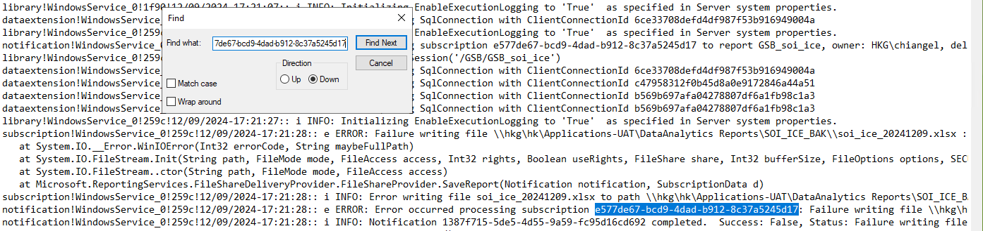

Possible cause of the error:

* The target folder does not exist or has no permission to access the target folder.
* The report template cannot connect to the source data.
* The report template is not valid or corrupted.
* A non-reporting services error was caused by the operating system.

### Power BI Semantic Model Refresh Failure

If an error is encountered during the refresh of the Power BI semantic model, an exclamation mark will be displayed next to the refresh timestamp.

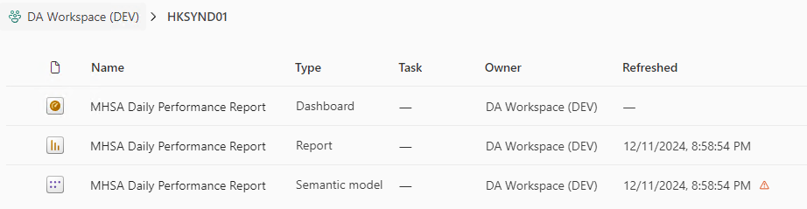

To view the details of the error, click on the exclamation mark. In the example below, the issue was caused by Power BI's failure to connect to the source database, which prevented it from retrieving and processing the data.

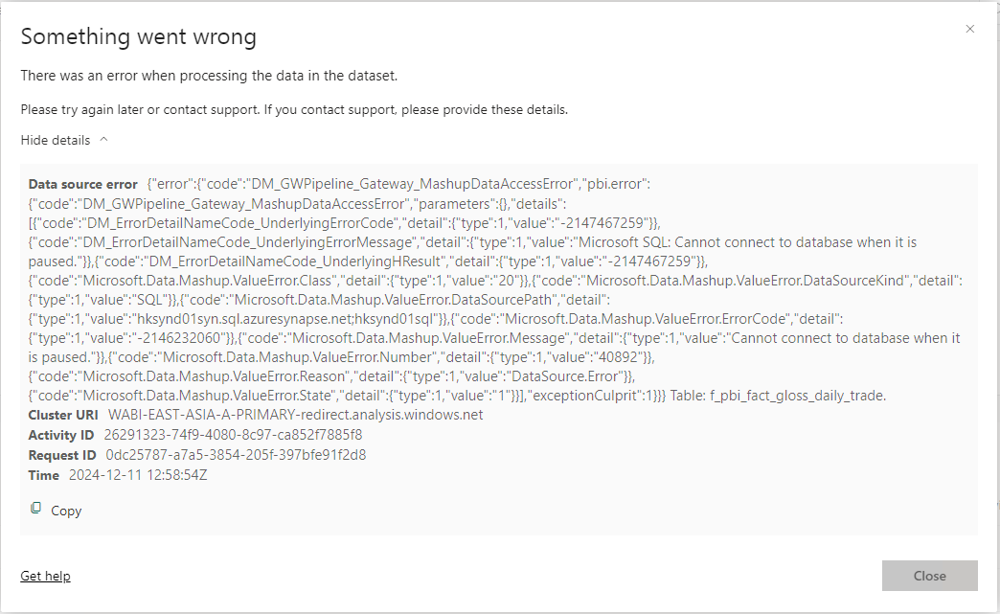

Possible cause of the error:

* The target database is inactive and not providing service.
* The login credentials to the database are incorrect.
* The data gateway cannot be connected.